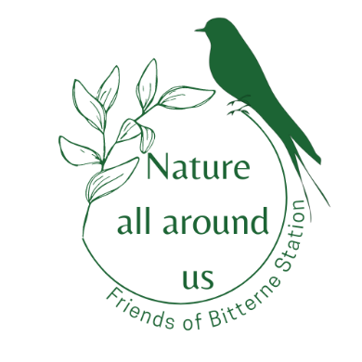
Nature all around us Photography Competition
SUBMISSION FORM

Please read the following guidelines and complete the fields below to enter the competition.
Simply email a copy of this form alongside the photo/ photos you are entering to bitternestationhub@gmail.com by the 7th of June 2023.
We will retain the email to contact you if your photo is selected to arrange the collection of your prize.
_ _ _ _ _ _ _ _ _ _ _ _ _ _ _ _ _ _ _ _ _ _ _

I confirm that the photo/photos attached have been taken by myself and I fully own the copyright of the materials submitted YES - NO (delete as appropriate)

I am happy for my photo to be used as inspiration for the artworks of the project “Nature all around us” by artist Joanna Rose Tidey YES - NO (delete as appropriate)

I am happy for the photos to be used by the project ‘Nature all around us’ to promote nature, the art trail and the project (online and offline). The photo/photos will not be used for any other project or commercial activity and the author (yourself) will always be fully acknowledged.
YES - NO (delete as appropriate)

Name (as you would like to be acknowledged as the author of the photos)
___________________________________________________________

The location where the photo was taken (approximate)
_________________________________________________________

Any other information or comment you would like to provide:

